To sum up, because of the tremendous gains in language and culture, students are highly recommended to participate in study abroad programs. Colleges and universities should require that their students take advantage of this opportunity while also aiding students in preparing for and maximizing their study abroad experiences. It is imperative that students learn to navigate the increasingly interconnected world by immersing themselves in diverse cultures as a fundamental component of their education. In a world made smaller and interdependent by technological advances, young talents with multilingual competence and global visions will be more prepared to succeed in their future careers.

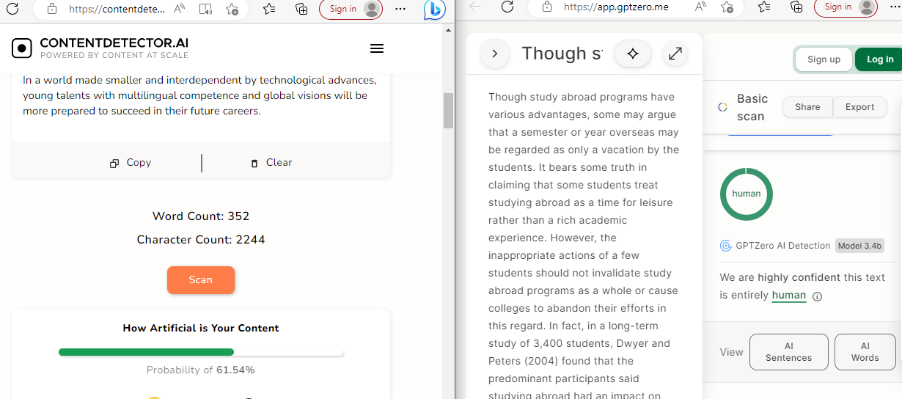

(The “References” must begin on a new page. Also, make sure that you use “Left Alignment” for your essay - not “Justification” which distorts the space between words.)

References
Brewer, E., & Cunningham, K. (2009). Capturing study abroad’s transformative potential. In E. Brewer & K. Cunningham (Eds.), Integrating study abroad into the undergraduate curriculum: Theory and practice across the disciplines (pp. 1-29). Sterling, VA: Stylus.
Dwyer, M., & Peters, C. (2004). The benefits of study abroad. IES Abroad News, http://www.iesabroad.org/study-abroad/news/benefits-study-abroad
Jochum, C. J. (2014). Measuring the effects of a semester abroad on students' oral proficiency gains: A comparison of at-home and study abroad. Frontiers: The Interdisciplinary Journal of Study Abroad, 24(1), 93–104. https://doi.org/10.36366/frontiers.v24i1.338
Kauffmann, N., Martin, J., & Weaver, H. (1992). Students Abroad, Strangers at Home: Education for a global society. Yarmouth, ME: Intercultural

